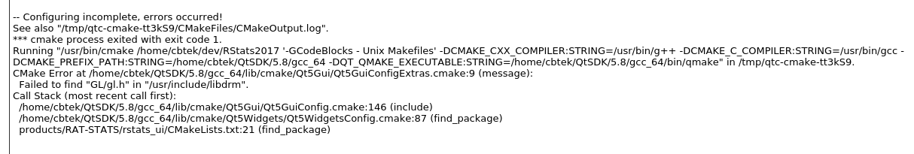
On Ubuntu 16.04 I get the following error after installing QtSDK and trying to use Cmake to generate configuration for a Qt GUI based project:

Solution:
I had to install libgl1-mesa-dev to fix this issue.
Debian/Ubuntu command: sudo apt-get install libgl1-mesa-dev

